Liverpool FC join the #Morethanfootball Action Weeks
Liverpool FC Foundation, the charity arm of the reigning English champions has joined the biggest campaign on community and social responsibility (CSR) initiatives by the continent’s clubs, leagues and FAs. They are joined by Croatia’s HNK Hajduk Split; Bijzondere Eredivisie, the league for children with various disabilities from the Netherlands and Heracles Almelo.
80+ clubs, leagues and FAs are taking part in the 2020 #Morethanfootball Action Weeks. The campaign is run for the European football community to showcase the impact of their community and social responsibility activities and programmes. It provides the wider European football family with a platform to inform and engage with fans and stakeholders on their CSR activities and raise awareness of the transformative role football plays in changing peoples’ lives for the better.
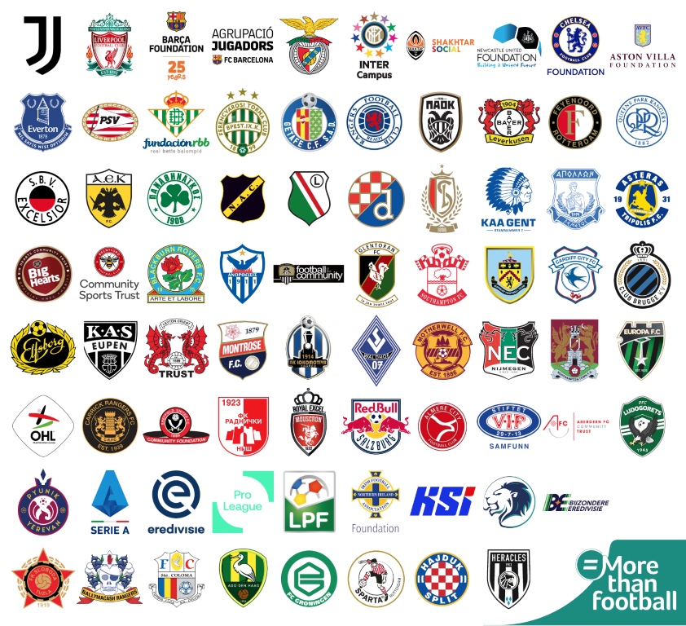
The #Morethanfootball Action Weeks began on 15 September and will go on until 11 October. To kick off, organisers European Football for Development Network (EFDN) and participating organisations shared their #WeAreMorethanfootball challenge showcasing their excellent CSR initiatives and explaining how their organisation is more than football. Two clubs and EFDN members, PAOK FC and Benfica, officially kicked off the campaign at Toumba stadium in Thessaloniki, Greece ahead of their UEFA Champions League qualifying third round match. The club captains – PAOK’s Dimitris Pelkas and Benfica’s Andre Almeida – signed a pledge supporting the aims of the Action Weeks to highlight the work their clubs and foundations engage in to impact the communities around them.
The Education Action Day on Friday 18 September was the first for clubs to highlight projects they have, are or will implement on their websites and social media platforms. A sample of these initiatives is found here.

PARTICIPATE IN THE CAMPAIGN
This week, the second of the campaign, is dedicated to various CSR concerns. Wednesday is the kick-off for the European Union’s #BeActive European Week of Sport and Special Olympics European Football of Week. Friday 25 September will be the Sport and the SDGS Action Day. Over the weekend – 26 & 27 September – the campaign will observe the Intellectual Disabilities Action Day. There is still time to join us in the campaign and participate in the More than Football Award.

